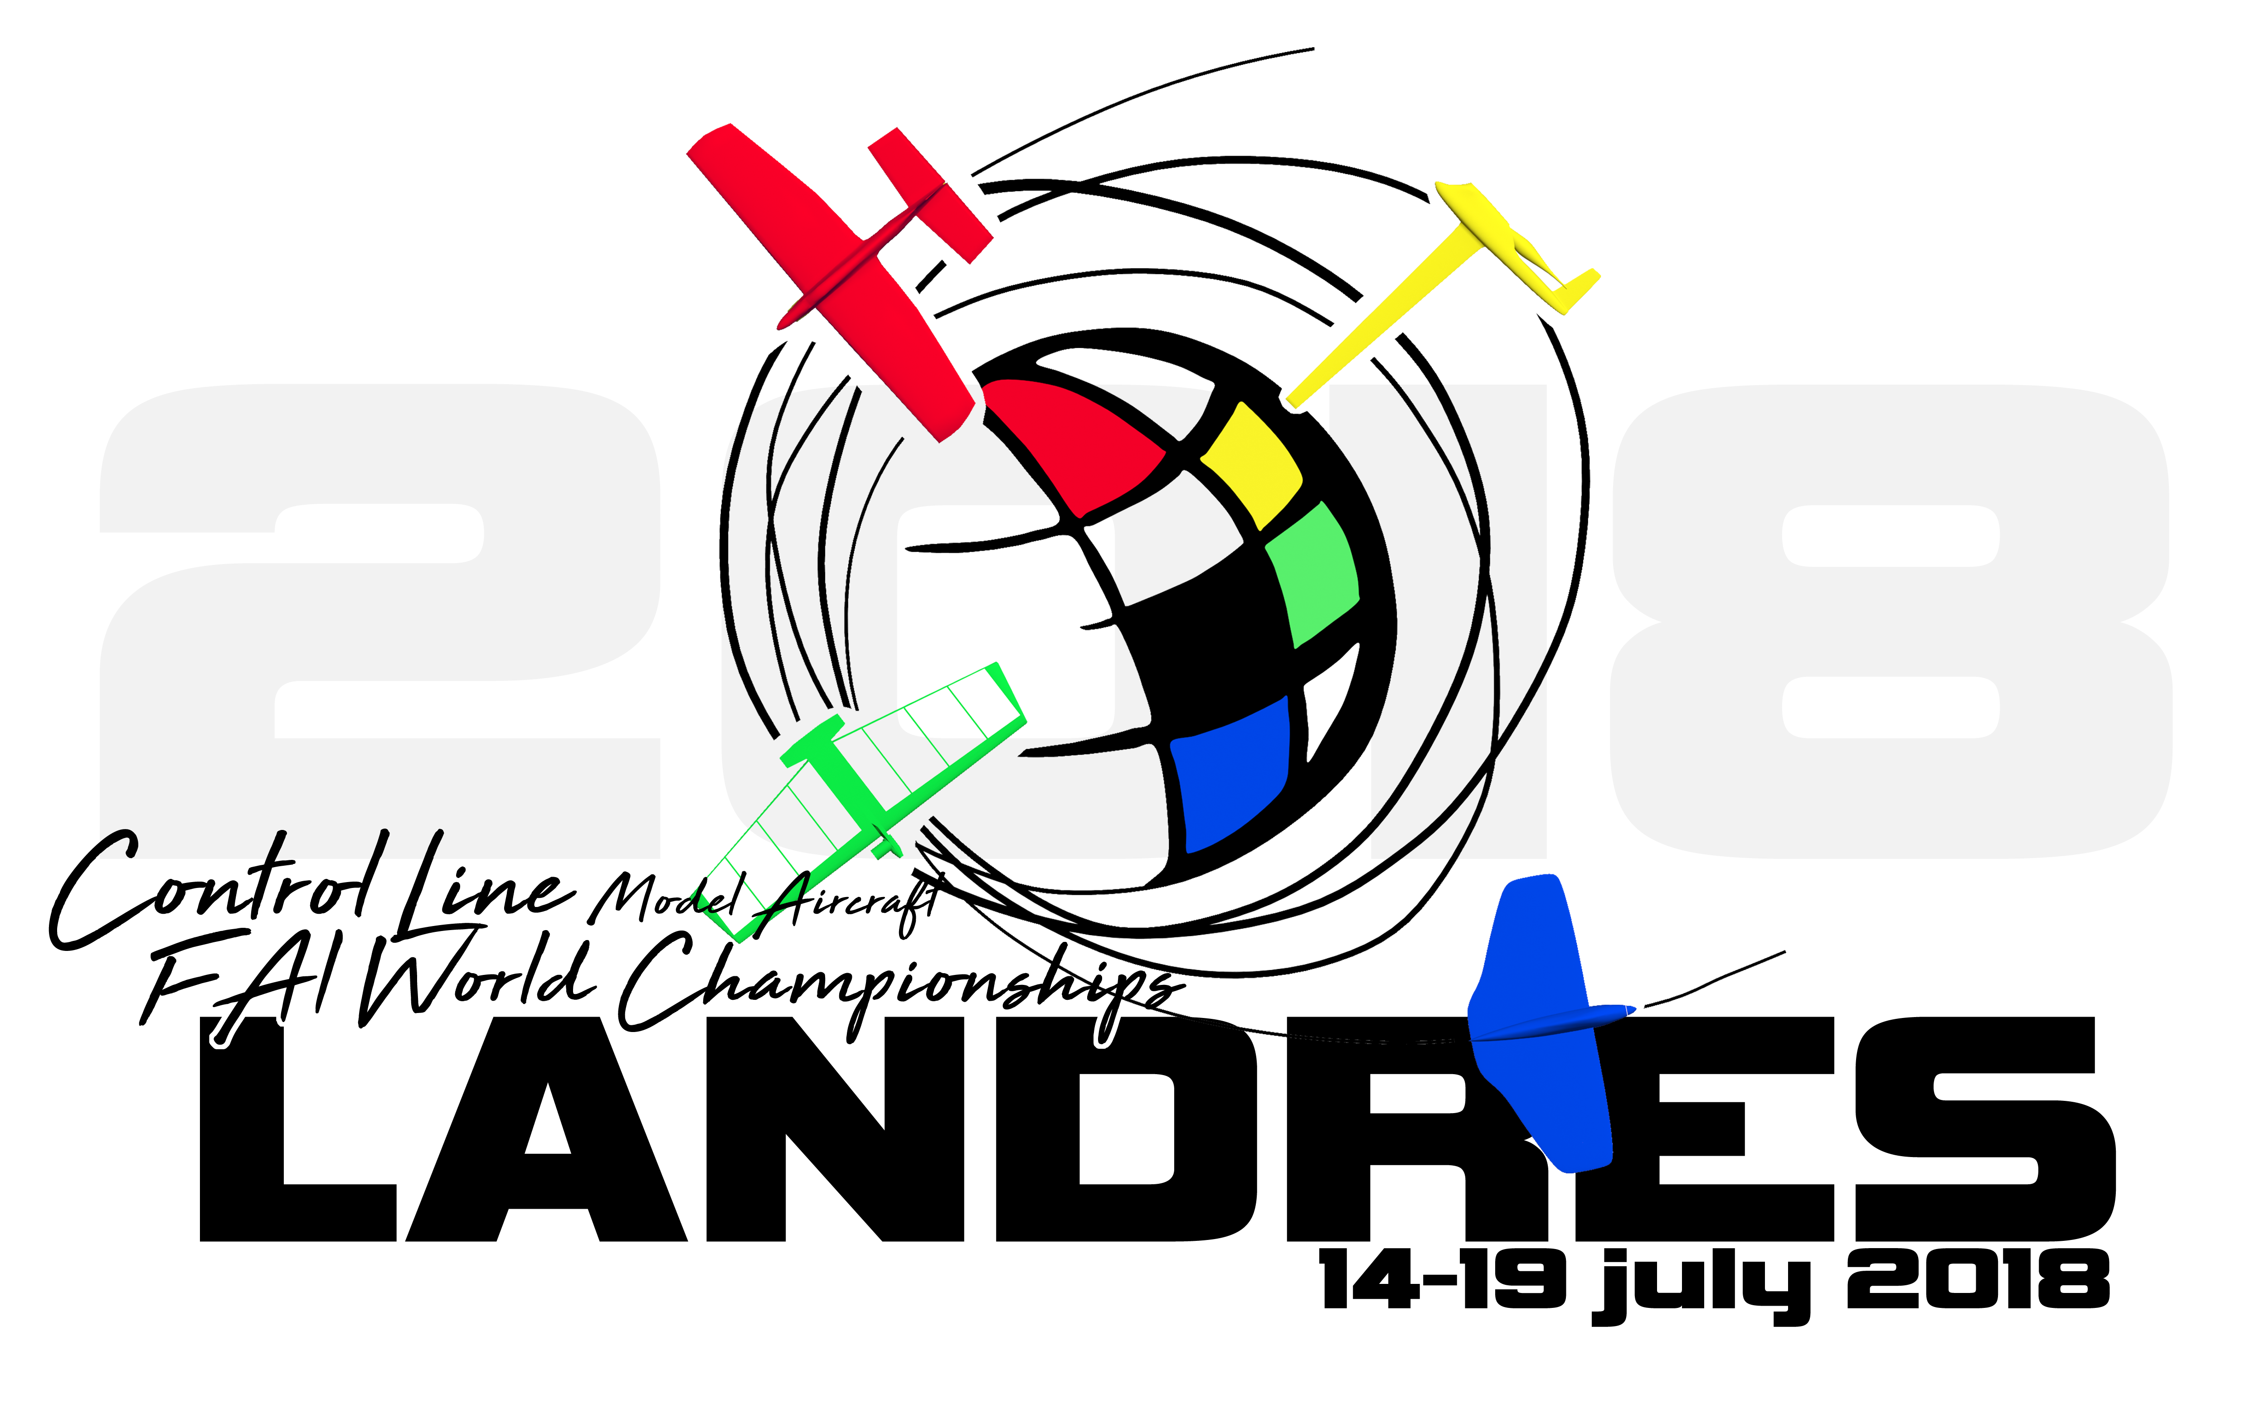

2018 FAI F2 WORLD CHAMPIONSHIPS

FOR CONTROL LINE MODEL AIRCRAFT

Bulletin 2 - March 2018

Landres - France
Saturday 14th to Thursday 19th July 2018
Arrival Friday 13th July - Departure Friday 20th July

World Championships website: http:// WC 2018.f2cmbl.org

ORGANISER AND LOCATION

The championships are organised by Federation Française d'Aéromodélisme (FFAM) and the Cercle Modéliste Blénod Lorraine (CMBL).
Landres is located in north east of France near the Belgian, Luxemburger and German borders.
By air the best airports are: Luxembourg, Frankfort, Paris, Bruxelles.
By train the easiest railway stations are: Metz and Luxembourg.
By road Landres is easy to reach by A31 (North/South) and A4 (West /East).

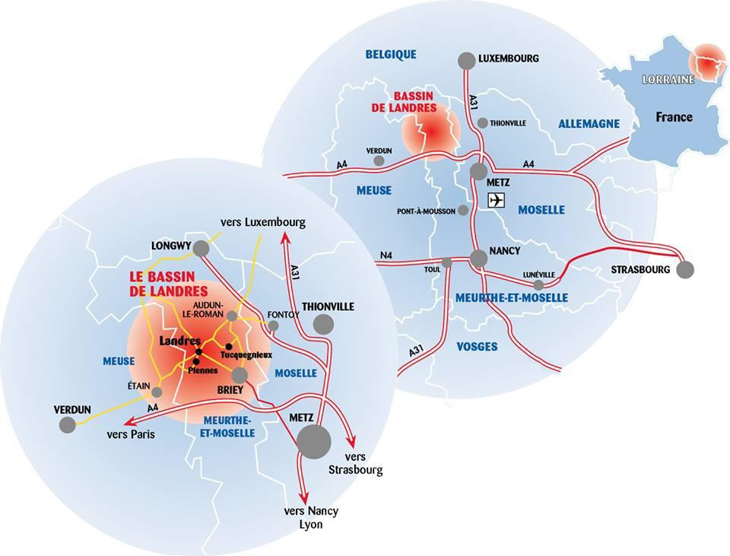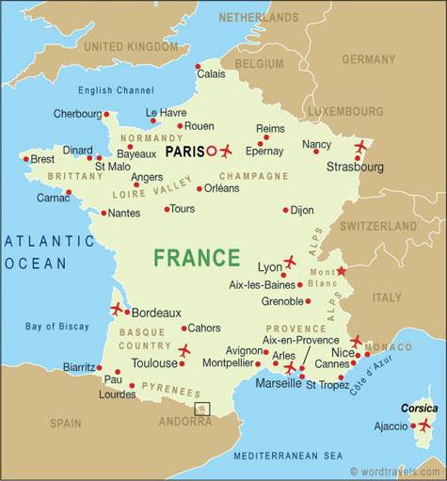

The competition will be run in the “Espace Victor Tatin” stadium totally dedicated to Control Line
GPS: 49°18'40"N 5°47'52"E
49,311252 5,798512

Altitude: 346 meters
Sunrise: 5 h 46 (UTC +2 hours), Sunset: 21 h 38 (UTC +2 hours)
Average temperature mid July 2017: 15°C at 7 h and 29° C at 13 h. Historical average temperature: 14°C / 23°C.
“ESPACE VICTOR TATIN” CONTROL LINE STADIUM
This picture shows all the equipment of the stadium on 1st November 2017. A new circle will be built next March (F2A circle).
According to the rules, depending of the number of competitors, it should be possible to use a 2 circles format. One of the circle surface is tarmac, the other with grass.

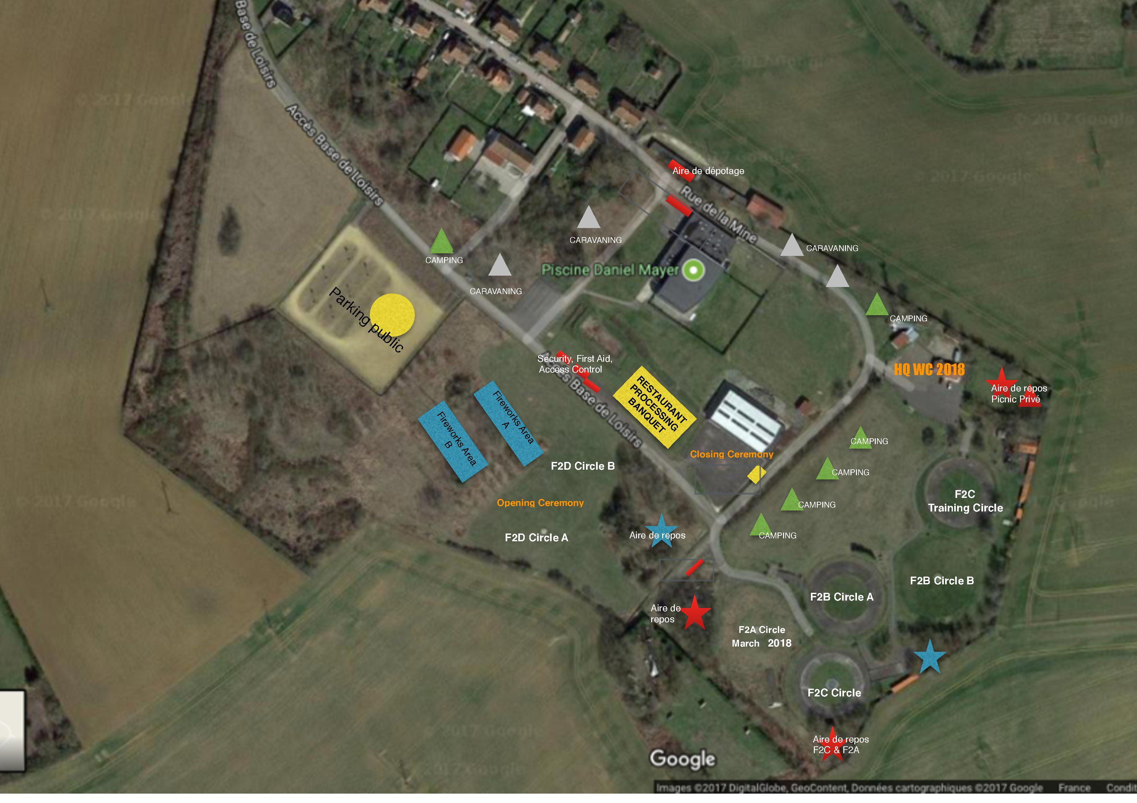

CLASSES

F2A, F2B, F2C, F2D Seniors and Juniors.

RULES

The World Championship will be run according to:
- FAI Sporting Code Section 4 Aeromodelling CIAM General Rules Volume 2018 Edition.
- FAI Sporting Code Section 4 Aeromodelling Volume F2 Control Line Models 2018.
- FAI General Section and FAI Code of Ethics.
Anti-Doping Statement: If a competitor has to take, for a medical condition, any of the substances listed on the WADA Prohibited List, he must have a valid Therapeutic Use Exemption (TUE) from the FAI.
FAI Sporting Licence: Each competitor, team manager and F2D mechanic must possess a FAI Sporting Licence valid for 2018. This licence must be registered in the FAI licences database.
The holder of a FAI Sporting Licence may be required to produce an official document bearing his photograph and signature as proof of identity.
Protest: Any protest must be presented in writing to the Contest Director and must be accompanied by the deposit of a fee of 50 Euros. The deposit is returned only if the protest is upheld.

OFFICIAL LANGUAGES

The official languages will be English and French.

CONTEST MANAGEMENT TEAM

F2A Contest Director: Làjos KANTOR (HUN)
F2B Contest Director: Uwe KEHNEN (GER)
F2C Contest Director: Fabrice PICARD (FRA)
F2D Contest Director: Yolanda GARCIA de FUENTES (ESP)

Coordinators:
- Lodging, Catering, Transports: Claire PERRET / Julie CANOVA
- Public Information / Internet Live / Scoring Systems: Laurent HENRY / Matthieu PERRET / Roland POIDEVIN / Fabrice PICARD
- Stadium Preparation and Maintenance: CMBL crew
- Fuel Officer: Albert DOHR
- Control Officers: Patrick CONSTANT / Jean MARET

OFFICIALS

FAI Jury
- Massimo SEMOLI (SUI) - President
- Kevin DODD (AUS)
- Jean Paul PERRET (FRA)
Reserves:
- Attila KASOLY (HUN)
- Marek DOMINIAK (POL)

F2A Speed
Head judge: Thomas SKRZEKUCKI (FRA) - Electronic timers Transitraces will be used.

F2B Aerobatics

Judges:
- Roger LADDS (GBR)
- Stefan KRAZEWSKI (POL)
- Richard ROUX (FRA)
- Henry KUROWSKY (RSA)
- Willi SCHMITZ (GER)
- Rogerio ALVES (BRA)
A 2 circle format will be used, so the Panel of judges will be as followed:
- Jury A: Roger LADDS (GBR) - Rogerio ALVES (BRA) - Richard ROUX (FRA)
- Jury B: Stefan KRAZEWSKI (POL) - Henry KUROWSKY (RSA) - Willi SCHMITZ (GER)
Reserves:
- Jean-Michel MAQUET (BEL)
- Franz OBERHUBER (AUT)

F2C Team-racing
Circle Marshall: to be decided

Judges:
- Bruno DELOR (FRA)
- Mike CROSSMAN (GBR)
- Max DILLINGER (AUT)

Reserves:
- Attila KASOLY (HUN)
- Valery KRAMARENKO (UKR)

F2D Combat
Circle Marshall and Judges:
- Ingemar LARSSON (SWE)
- Pavol BARBARIC (SLO)
- Vernon HUNT (GBR)
- Frédéric MONNIER (FRA)

COMPOSITION OF A NATIONAL TEAM

Every National Airsport Control may enter a team consisting of:
- A team manager and an assistant team-manager.
- A maximum of four competitors provided that the fourth one is a junior (age limit 18 years in the year 2018).
- Helpers and supporters.
The reigning F2A, F2B, F2C, F2D World Champions (junior and seniors), have the right (subject to the approval of his NAC) to participate in the championships regardless of whether or not they qualify for the national team. If they are not members of the national team, their scores or places will not be considered in the team results.

CLASSIFICATION AND AWARDS

Individual classification
FAI medals and FAI diplomas will be awarded to the competitors placed first, second and third.
For the additional Junior classification, FAI medals and FAI diplomas will be awarded to the competitors placed first, second and third. In order to award the title of Junior World Champion, junior competitors from at least four nations must participate in the class.

Team classification
FAI medals and FAI diplomas will be awarded to each member (or team in F2C) (including the fourth team member (or team in F2C) when appropriate and the team manager) of the teams placed first, second and third.

Trophies
The following CIAM perpetual trophies will be awarded:
  - F2A Individual - Netherlands Cup - Current holder: Paul EISNER (GBR)
  - F2A Team - Leonardo da Vinci Cup - Current holder: Ukraine
  - F2B Individual - Steve Wooley Cup - Current holder: Orestes HERNANDEZ (USA)
  - F2B Team - Jim Walker Team Trophy - Current holder: USA
  - F2C Individual - Paul du Toict Challenge renamed as Kupok Challenge Trophy - Current holder: Robert FITZGERALD / Mark ELLINS (AUS)
  - F2C Team - Asboth Oszkar Cup - Current holder: Australia
  - F2D Individual - Castrol Trophy - Current holder: Illia REDIUK (UKR)
  - F2D Team - Combat Team Trophy - Current holder: Russia
Other trophies or awards will be awarded by the organiser.

PRELIMINARY SCHEDULE

13 July 2018 | Arrival - Registration - FAI Jury Meeting - Technical team manager Meeting
14 July 2018 | Technical Processing - Official Practice - Opening Ceremony
15 July 2018 | F2A Flight 1 | F2B Flights 1 & 2 | F2C Round 1 | F2D Rounds
16 July 2018 | F2A Flight 2 | F2B Flights 1 & 2 | F2C Round 2 | F2D Rounds
17 July 2018 | F2A Flight 3 | F2B Flights 3 & 4 | F2C Round 3 | F2D Rounds
18 July 2018 | Reserve day | F2B Flights 3 & 4 | F2C Semi-final 1 | F2D Rounds
19 July 2018 | F2A Flight 4 | F2B Fly-off 1 to 3 | F2C Semi-final 2 & Finals | F2D Semi-finals & Finals
 | Official Prize-Giving Ceremony - Banquet
20 July 2018 | Departure

ENTRY FEES

- Team-manager and assistant team-manager: 290 Euro
- Senior competitor: 290 Euro
- Junior competitor: 100 Euro
- Helper, supporter or F2D mechanic: 50 Euro
A competitor who is also a team manager will only by one entry fee of 290 Euro.
If a competitor registers in more than one class a 50 % discount shall be offered on the second entry fee.

DEADLINES

- Preliminary Entry form (intent to enter a team with number of competitors for each class): Some NAC seem to be late, so please send pre entry forms as quickly as possible
- Final Entry Form (official entry including competitor's names and FAI Licence ID number) and payment of the entry fees: 30th April 2018.
Entry fees received after the deadline may be subject to a penalty fee up to 20 % of the total amount of the entry fees to be paid.
Entry fees will not be accepted on arrival except in exceptional circumstances and with the agreement of the organiser.
If a competitor or a team withdraws from the World Championships after having paid the entry fees, a refund will be considered only in case of force majeure or exceptional circumstances.

FOOD
Breakfast on the site: 8 €
Lunch or dinner on the site: 15 €
Banquet: 50 €
All the reservations have to be done in using the “meals order form” included in this bulletin.
It is possible to have a dinner in local restaurants and hotels for about 25 €.

LODGING
An Annex "Accomodation" was enclosed at the end of the Bulletin N°1 and also available on the World Championships website: http:// WC 2018.f2cmbl.org
Two types of management for hotel accomodation:
- A list for the hotels you can book by yourself.

2. A list of hotels near in which the organiser already booked 140 rooms. For this service ask the organiser and send your needs. We ask the team managers who want some help to book hotels through our way, to contact Jean Paul PERRET jpperret1@gmail.com Some team managers contacted him to book rooms in several hotels. So Aster Hotel has no more room, there are 12 rooms remaining in IBIS hotel, and 10 in Hotel du Nord. We reserve “Premiere Classe Hotel” for the people who expected to lodge in the technical school near the stadium.
Lodging in the dormitories of the technological school of Landres (very close to the site) is not possible. We booked “Hotel Première Classe” in Longwy. If necessary transportation from the hotel to the stadium will be organised for the competitors and back (twice a day). That means around 100 people may lodge in this hotel. (19 €/pers/night + 6 € breakfast)
Bed and breakfast, or guest rooms, are also possible, all of them on a radius of 40 km are noticed in a list enclosed in the Annex “Accommodation”. If you need help contact the organisation.
To avoid mistake or misunderstanding contact directly JP Perret.
On site, camping will be available for camper vans, cars and tents. There are toilets, showers and electricity supply. Book your place with the “camping reservation form”

INSURANCE

The organizer will provide a limited third-party liability insurance covering all competitors for model accidents involving injury to others and damage to property (1 247 961 € amount of coverage). According to French legislation, this insurance will also cover injury to others and damage to property or people by accidents caused by the organizer or staff members during the championship period.
Individual health coverage as well as travel insurance purchased before arrival in France is recommended.
For EU citizens, health care is covered under Social Health Care on presentation of an EHIC card EU 111 form available in the country of residence.
Citizens from outside of EU should provide their own health insurance to cover illness and travel insurance.

COMPLEMENTARY INFORMATIONS

Model Aircraft Specification Certificate
All models must be processed by the competitor's NAC in accordance with CIAM General Rules C.12. Model aircraft not properly processed by the NAC, with FAI certificates and stickers, will be processed by the organiser at a cost of 8 Euro for each model.

Visa requirements
For citizens from some countries outside of EU, a visa may be required to enter France. For more information, please enquire in your own country.

Registration of the national teams
When registering his national team, the team manager must bring the following items.
- Copy of banking payment receipts.
- Two national flags (approx. 1 m x 1.5 m).
- National anthem.
- List of the team member's FAI Sporting Licence Unique ID numbers.
The Model Aircraft Specification Certificates will be required for processing.
At the registration, the team manager will receive the following items for his team: ID cards, souvenirs, ordered meals and banquet tickets, etc.

Transportation
Buses will be arranged for transportation to the banquet.
If some national teams need some specific help, they may ask the organizer.
Buses will be arranged from “Première classe Hotel in Longwy” to the Stadium (and back) twice a day if necessary.

Fuel and batteries
Fuel components will be available on the spot (on orders only). A form order for fuel components is attached to this Bulletin.
The national teams may send their own fuel or batteries to this dedicated address: CMBL CM 2018 Jean Paul PERRET 1 rue Jean Jaurès 54640 TUCQUEGNIEUX.

Communication
The site will be opened to public all through the competition.
A live scoring system with a large LED display will be used for public information during flights. Video screens will also be available for competitors and team managers to see real time scores and unofficial placings.
Video streaming will be available on Internet.
An effort will be done in order to have the best coverage of the World Championships by medias.

Tour
As everybody knows, East of France was the theatre of the biggest fights of World War 1. The town of Verdun became the symbol of the Great War. This terrible period of the world history ended in 1918. Events organised for the centenary of the end will be held in Verdun on 20 and 21 July. Verdun is close from Landres and a tour will be proposed on Saturday with special rates. All information will be given later.

Bulletin 2
Bulletin 2 including the Final Entry Form will be published on 15 March 2018 on the website of the World Championships. Bulletin 2 has been sent by mail to the NAC's and team manager which have returned a Preliminary Entry Form.
With the Final Entry Form, a passport size photograph will be required for each participant, helper and supporter in order to prepare the ID cards.

ORGANISER CONTACT DETAILS

Cercle Modéliste Blénod Lorraine CM 2018
Correspondance address: 1 rue Jean Jaurès - 54640 - Tucquegnieux - France
Email: matth.perret@gmail.com

BANK INFORMATIONS FOR PAYMENT

Bank information: CMBL CM 2018
IBAN: FR76 1610 6100 0796 0093 0102 727 BIC: AGRIFRPP861
Please note that all bank charges are the responsibility of the debtor.
Beneficiary: CMBL CM2018 1 rue Jean Jaurès - 54640 – Tucquegnieux
The payment has to be done before 30th of April.
It concerns registration fees (competitors, helpers, supporters), Lodging , meals, fuel.
Please do mark every payment with "WCh F2ABCD 2018”

